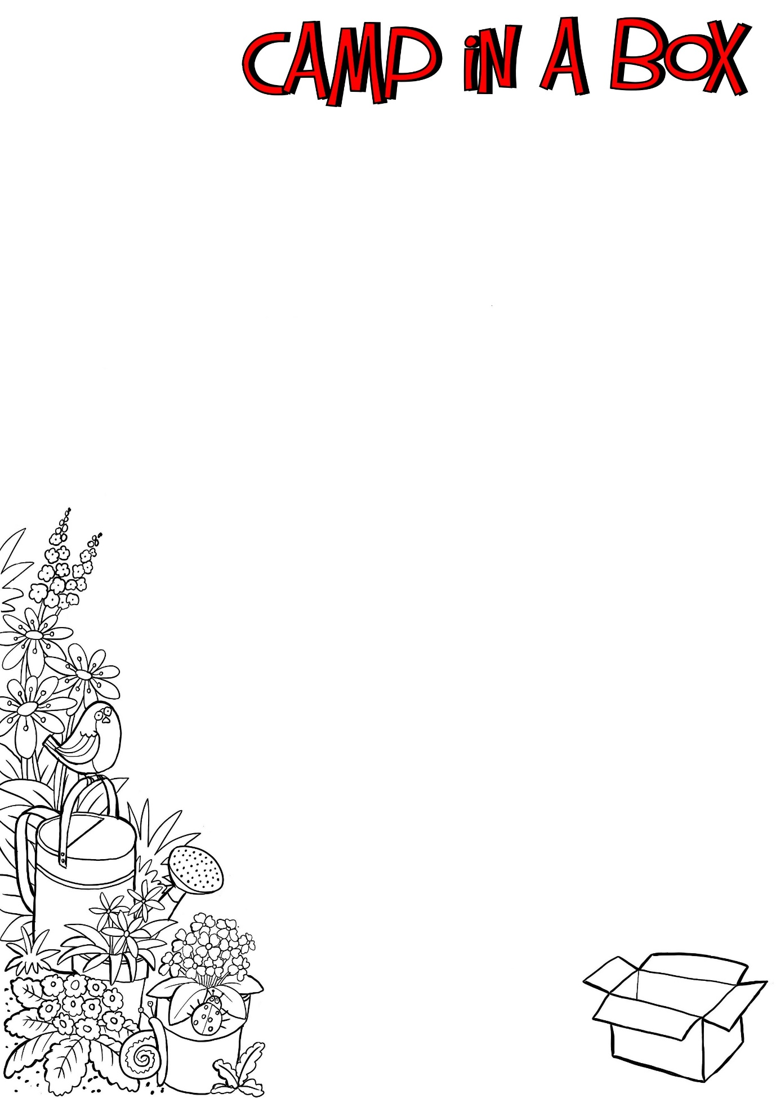
Ingredients:
110g of Butter
110g of Sugar
110g of Self-Raising Flour
2 Eggs (Large)
Cupcake cases have been included in your box
Ingredients:
110g of Butter
110g of Sugar
110g of Self-Raising Flour
2 Eggs (Large)
Cupcake cases have been included in your box
Cupcake Recipe

