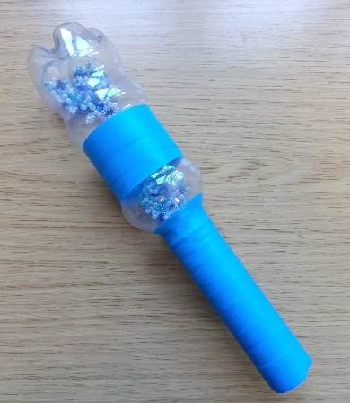
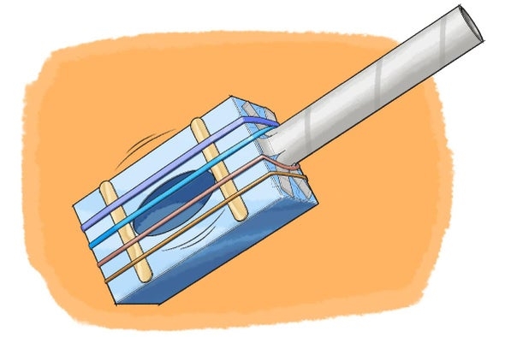
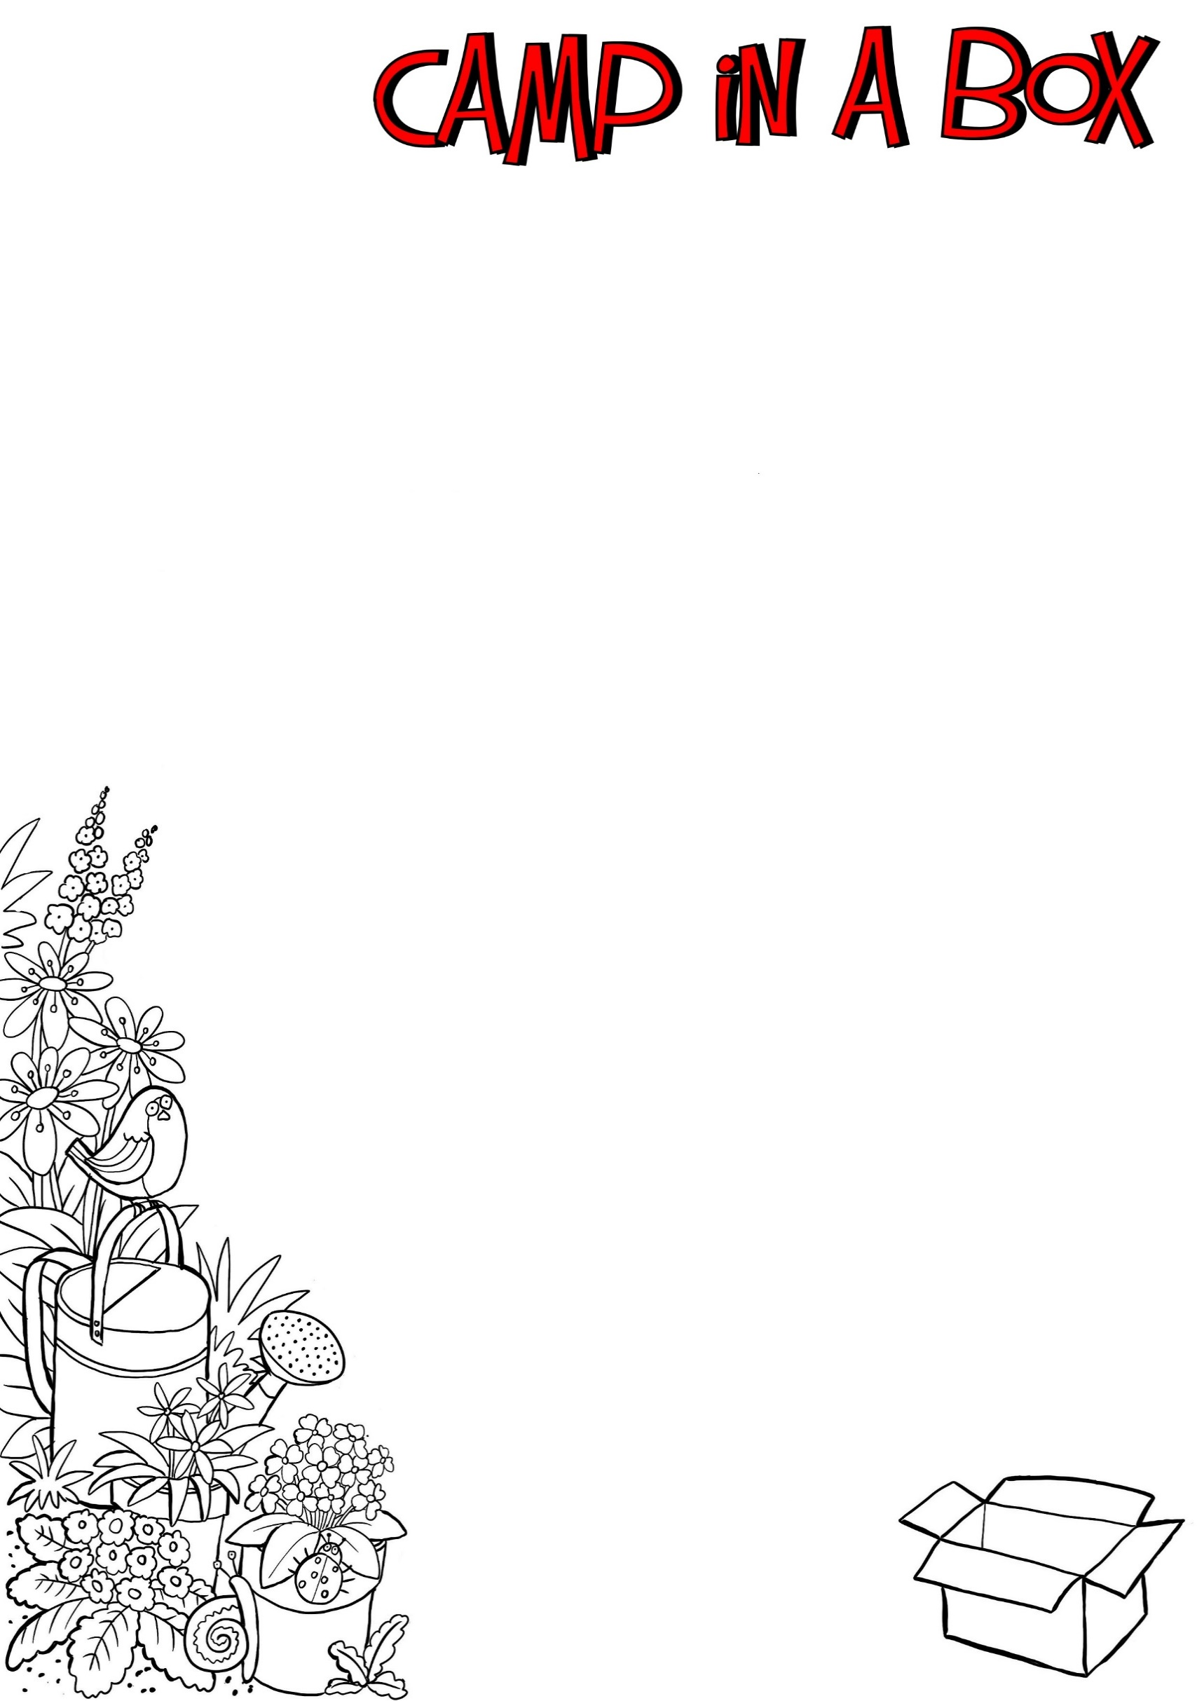
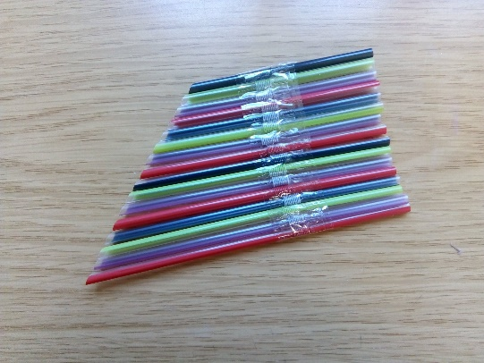
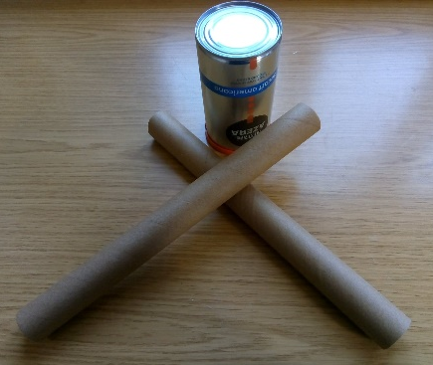
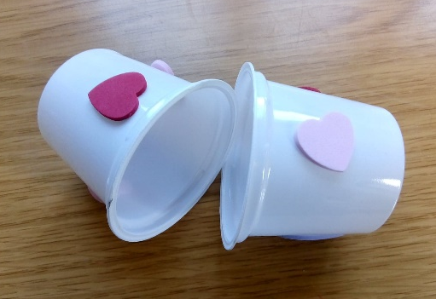
Have a look online for some more great ideas!

MARACCA
Plastic Bottle, 1/2 Cling Film roll, Insulation Tape, Filling!
Pour filling in bottle & screw cap on tightly. Push roll down over bottle top & tape in place.

What do you have in your recycling boxes?
Why not have a go at using things you find in your recycling to make some musical instruments (make sure they are clean first!)
Here are a few ideas……

www.scientificamerican.com
PAN FLUTE
Straws, Sellotape, scissors.
Place straws in a line & tape together. Cut the straws.

DRUMS
Coffee tin (or any other container!) 2 cling film rolls

You can use as they are or decorate!

CLIP CLOPS
2 Yogurt Pots
Decorate pots & then make some noise by gently hitting the rims together.

Making Musical Instruments
We would love to see your creations!
Why not have a go at making some music & playing them during your Camp In A Box Zoom session today.

