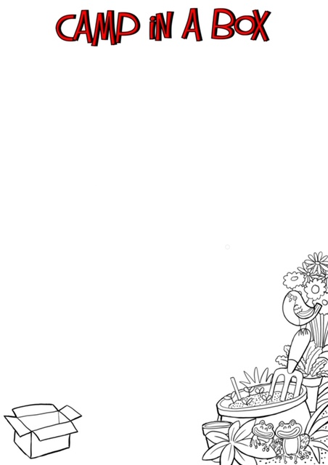
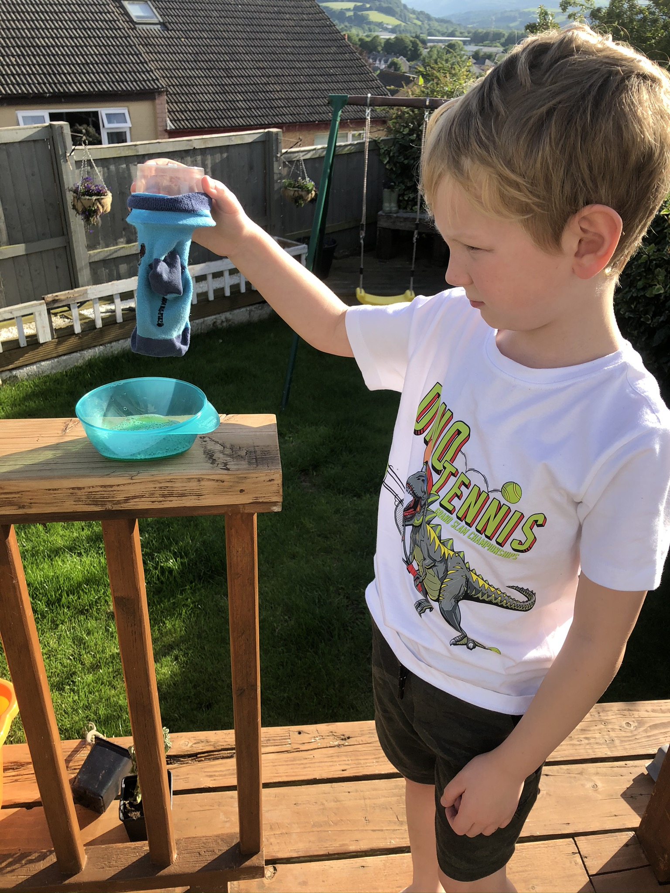
Don’t forget to show us how long you got your snakes either on zoom or by taking a photo and sending it to your group leader.
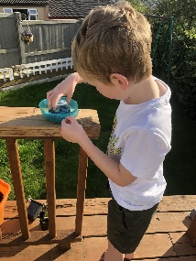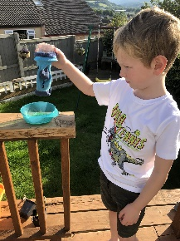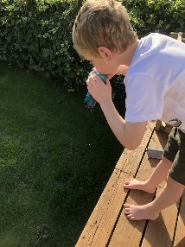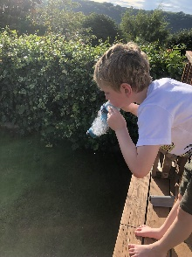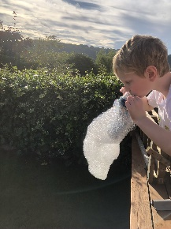

Bubble Snakes

You will need: Liquid dish soap

An old sock

Water bottle or yoghurt pot

Scissors

Bowl

DIRECTIONS
- Cut the bottom off water bottle using your scissors or if using a yoghurt pot make a hole in the bottom the size of the diameter of a pencil.
- Put your sock over the bottom of the water bottle/yoghurt pot.
- Pour some dish soap into a small bowl and add water, just about a 1/2 inch deep.
- Dip the sock end of your water bottle/yoghurt pot into the bowl of soap to coat the bottom.
- Place your mouth around the water bottle/yoghurt pot hole and blow! Keep blowing long and shallow breaths so the bubbles GROW in to a snake.

See who can make the longest snake!

