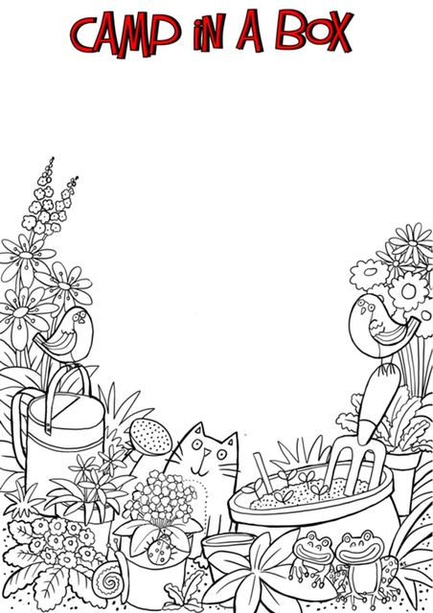
This challenge will NEED a responsible adult to participate:
Using objects from around your home safely build the highest structure you can, strong and secure enough to carefully place the youngest member of your family on the top!
Don’t forget to measure it to see if your structure is the highest of camp!
Please be careful as we don’t want any trips to A&E!!

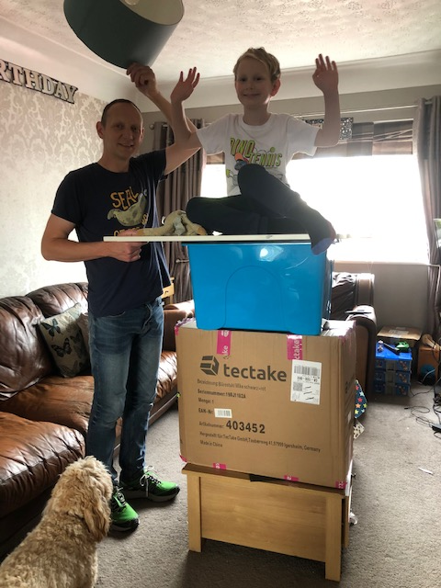
Building the highest structure

