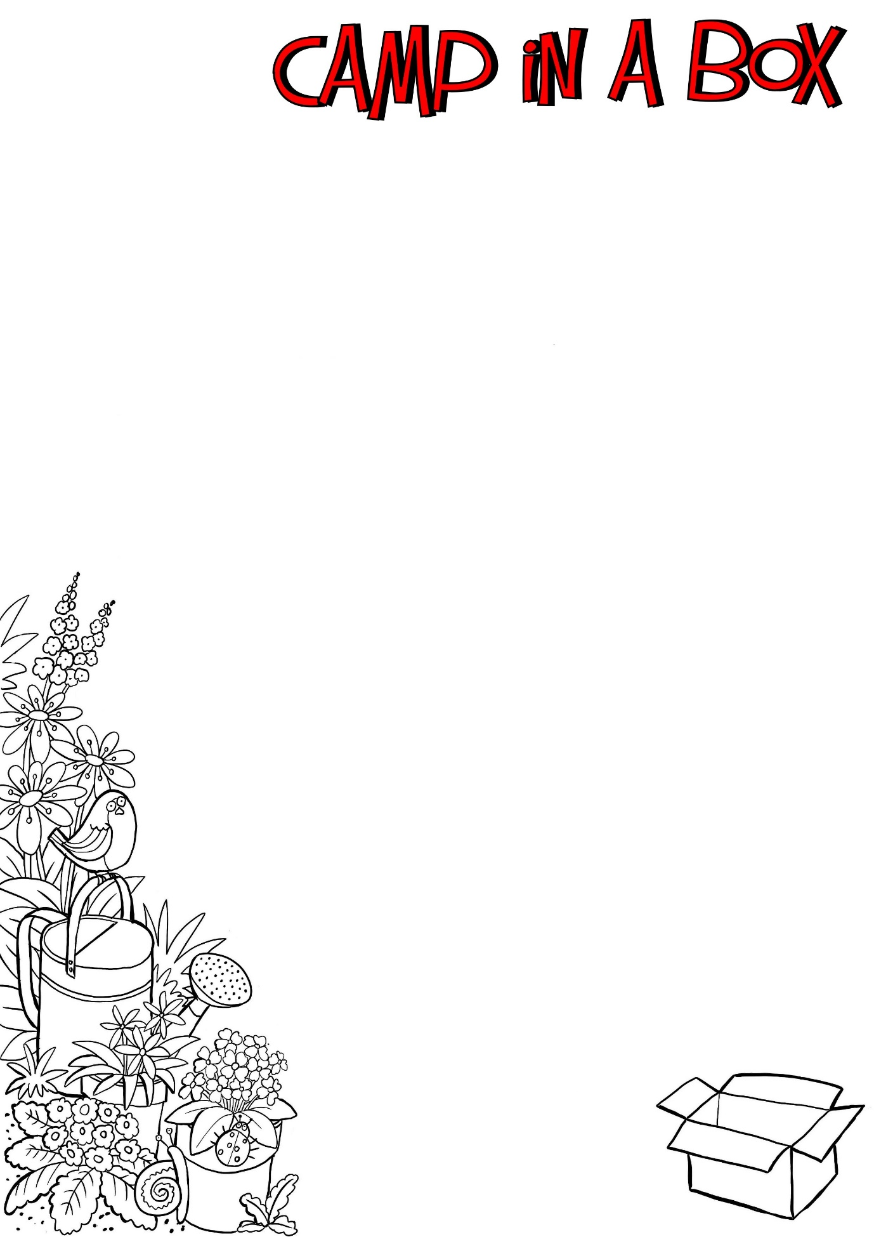

Acts of Kindness

Jesus said love your neighbour.

It is always feels good when someone does something nice for us. During this camp weekend, let’s do what we can to show kindness to those around us. Below are some ideas to use:

**These are just a few examples, have fun thinking up more!**

Ask someone to play their favourite game

Share the cupcakes you have made. (There is a recipe and some cases inside your box)

Ring someone to see how they are

Set the table for dinner

Make someone laugh

Tidy a room without being asked

Draw someone a picture

Create someone a ‘Thank You’ card